Media Release

Digicel supports Namatan Short Film Festival
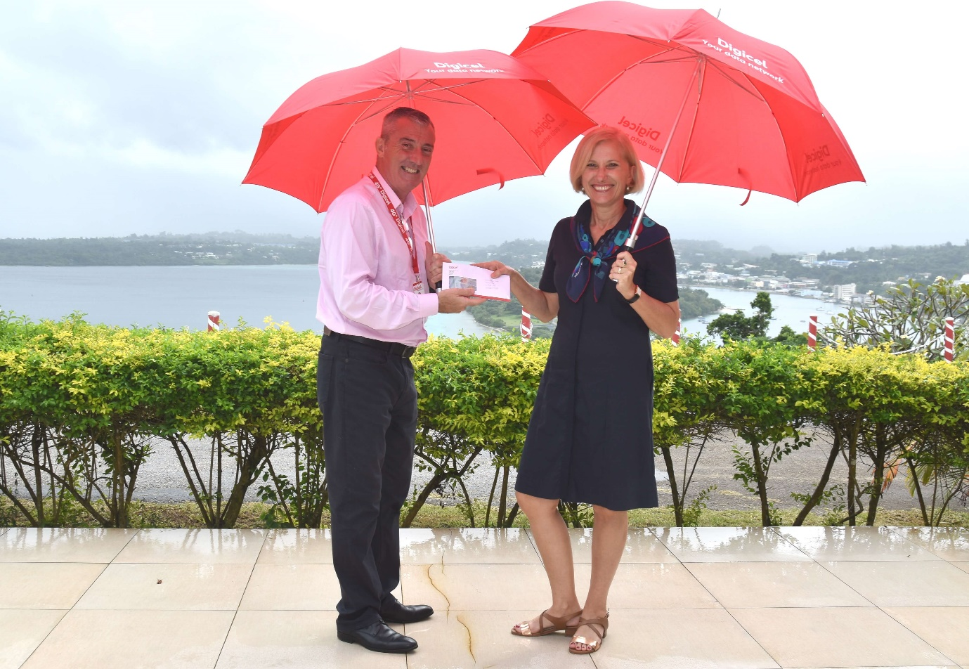
The Australian High Commissioner Jenny Da Rin receiving the Namatan sponsorship funding from the Digicel CEO, Ben Kealy.
The countdown is on for Vanuatu’s film makers to submit their films in time for this year’s Australian High Commission Namatan Short Film Festival, with entries closing on Monday, 13 May.
This week long-term Namatan sponsor, Digicel officially handed over sponsorship funding of Vt750,000 to the Australian High Commission to contribute to the organisation of Vanuatu’s premier film festival.
“We truly appreciate Digicel’s generous cash contribution to enable the Namatan Short Film Festival to continue to be enjoyed by the people of Vanuatu, and to provide Vanuatu’s film makers with the opportunity to tell their own stories via film,” said Australian High Commissioner, Jenny D Rin.
Digicel Vanuatu CEO, Ben Kealy said; “Digicel’s sponsorship is on top of an array of fantastic technology prizes for the winning filmmakers. We are especially excited to be supporting Namatan this year with school prizes for school-aged contestants – encouraging art and entertainment at the grassroots level. It ties in nicely with Digicel’s PlayGo app where Digicel customers can now watch TV on their smartphones.”
School prizes are a laptop for first place, a projector for second place, and a Samsung Tablet for third place. Contestants in the open category will vie for a brand new Samsung S8 for second place, a Samsung J5 for third place, and a Samsung Tablet for the People’s Choice Award winner. The overall winner will take-way 200,000vt cash, thanks to ANZ Vanuatu.
Namatan sponsor, Air Vanuatu is ensuring finalist’s films are screened across Vanuatu before debuting in Port Vila in June.
All films entered in 2019 must include Namatan’s ‘unique item’, a traditional Vanuatu woven basket. The woven basket was chosen to symbolise Vanuatu’s ban of plastic bags and to promote the use of traditional handicraft to support Vanuatu’s local economy.
Entries for the Australian High Commission’s Namatan Short Film Festival must be lodged with Festival partner, Vanuatu Broadcasting and Television Cooperation (VBTC) by 4.30pm this Monday, 13 May 2019. Terms and conditions apply and more information is available on the Australian High Commission’s website and Facebook page.

–END–
To know the latest about Australia in Vanuatu please follow us on:
Web | Facebook | Twitter

Liz Harris
Public Affairs Officer
Australian High Commission
Email: elizabeth.harris@dfat.gov.au
Tel: 22777 (extension 171)
Mob: 7776386

